**PATIENT REGISTRATION**

**Introduction:**

* Patient Registration is individual “Stand Alone”, browser based application to register patients and assign MR #.
* Patient Registration application is developed for the hospitals to facilitate registration process and generate MR # as per their requirement.
* Patient Registration Application is developed as separate entity to plug-in with (on Single Server);
  1. Any HMIS
  2. wrist band printing application.
  3. Patient test order and
  4. Specimen collection
  5. Panacea
  6. Haemovigilance Application
* Interfacing with National Database Record to collect Patient Record by National ID # i.e. this application should be developed in a way that it can be interfaced with any third party software and transfer data. This plugin will be developed when a client request it.
* Generic code for 20.4.13.1 – Drop down selection of all cities of the country in which application is deployed.
* Generic requirement for infinite scroll bar on each screen where multiple record found

**Cross Reference:**

* Generic SRS # G1, G2& G3.
  + G1 - Number Generation - Application Deployment Process
  + G2 - Login Screen
  + G3 - Password Reset Policy

**General Instructions:**

* Entry Fields: Alpha / Numeric / Symbols all are allowed to be entered
* Auto Fill: Independent of upper case / lower case.

**Thumb Impression:**

* A developer is dedicatedly assigned from Thumb Impression device integration with NARRO. Whenever integration is successfully done, it will be deployed with NARRO.

**Important Design Instruction;**

* Narro, Name & Icon to be displayed on each screen.
* Each screen should be designed to display organization name on the top

**Patient Registration**

**Figure 34**

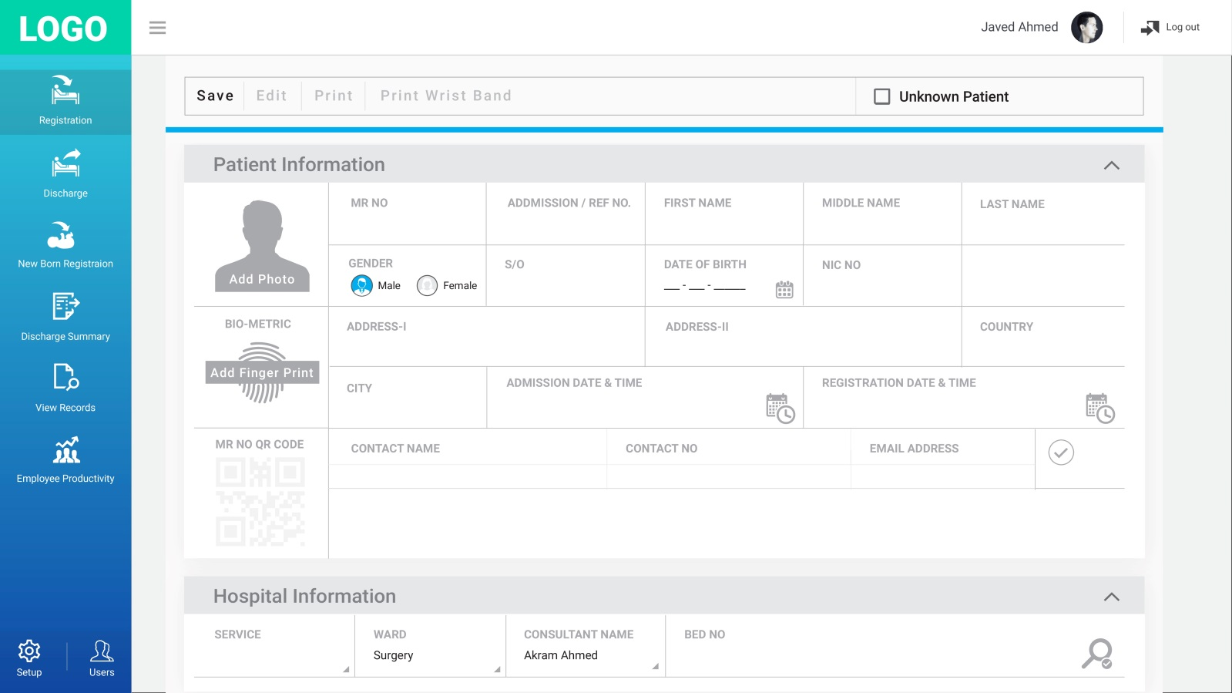

* 1. There is a requirement to select the Register button to access the patient Registration screen.

**Patient Registration**

**Figure 35**



* 1. There is a requirement that Patient Registration screen (as setup by institute) shall be displayed
  2. There is a requirement to enter Patient Information by the user.

**Patient Registration**

**Figure 36**

* 1. There is a requirement to assign auto generated MR no on selection of save button to on first time registration of the patient with date & time stamp.
  2. There is a requirement to assign auto generated admission number on selection of Save button, in each new admission, if admission number field is selected as compulsory
  3. There is a requirement to display current Date and Time (on selection of save) as Registration (first admission only) any admission Date and time.
  4. There is a requirement that Registration Date and Time and MR. No. is “Non-Editable” fields.
  5. There is a requirement if patient is not discharged i.e. discharge completed, the readmission is not allowed.

**Patient Registration**

**Assign MR Number**

**Figure 37**

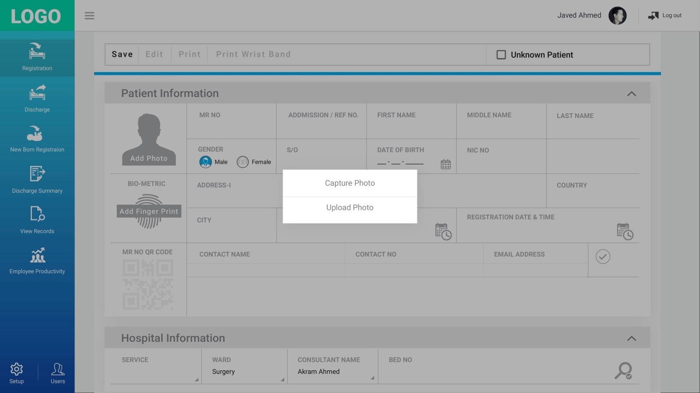

* 1. There is a requirement for upload photo or capture photo of the patient.
  2. There is a requirement for display fields for selected biometric information.
  3. There is a requirement for transmission of biometric information through device interfacing.

**Patient Registration**

**Assign MR Number**

**Figure 38**

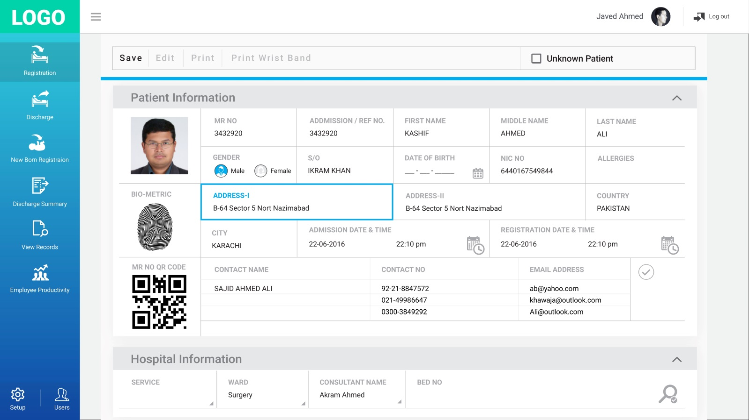

* 1. There is a requirement to have an option to Edit any field except MR #, Admission number, registration date and time and admission date and time.
  2. There is a requirement that any changes made during edit should be saved in database (i.e. all edited data saved along with username, date & time) i.e. date & time stamp. Complete traceability for edit.
  3. There is a requirement that Edited Record shall be displayed in different colour.
  4. There is a requirement to display “Print Wrist Band” button after assignment of “MR #”
  5. There is a requirement for Reset button to reset screen for new Admission / Registration.